**LAB ASSIGNMENTS**

Akshit Puri

Cyber Security, Loyalist College of Applied Arts and Technology

CYSE2001: Secure Network Infrastructure

Instructor: Peter Wheeler

27th September 2022

**LAB – 5:**

PC1 pings to PC3

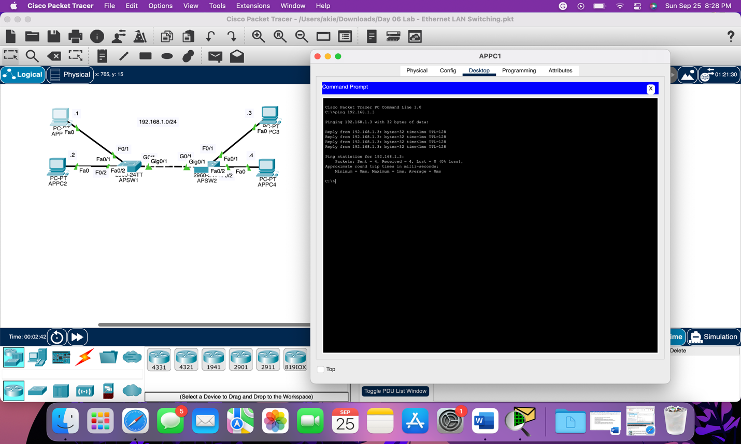

Send the ping and use Packet Tracer's 'simulation mode'

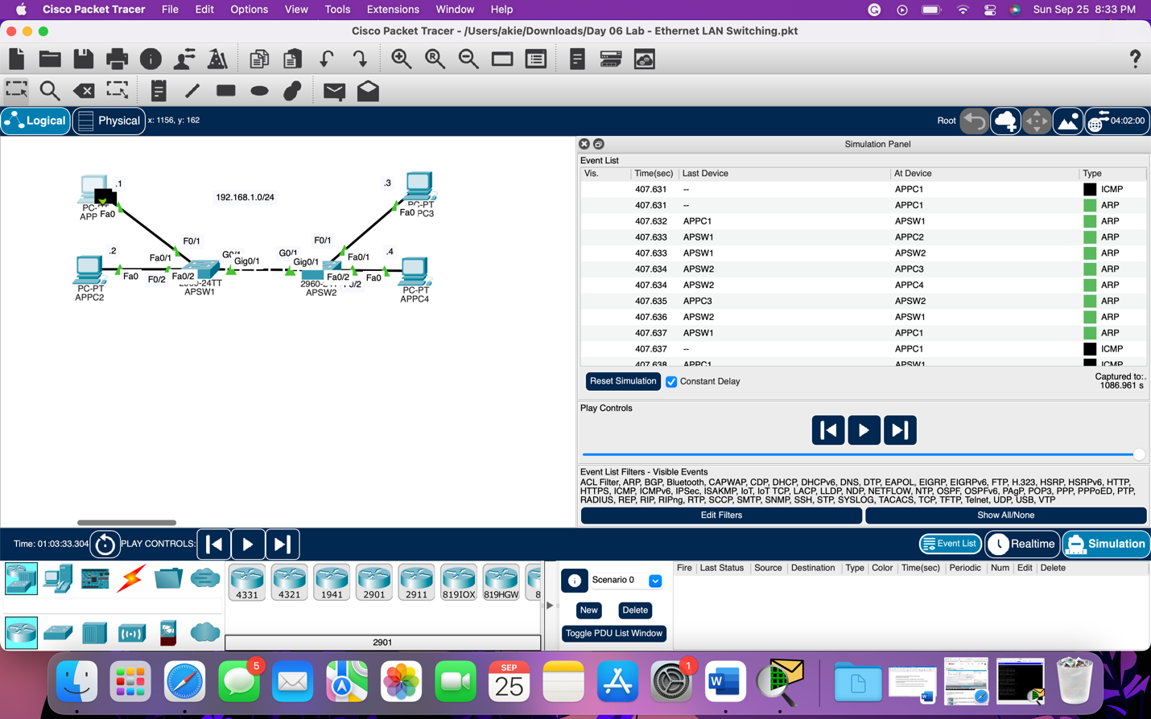

Use pings to generate network traffic and allow the switches to learn the MAC addresses

of all PCs on the network

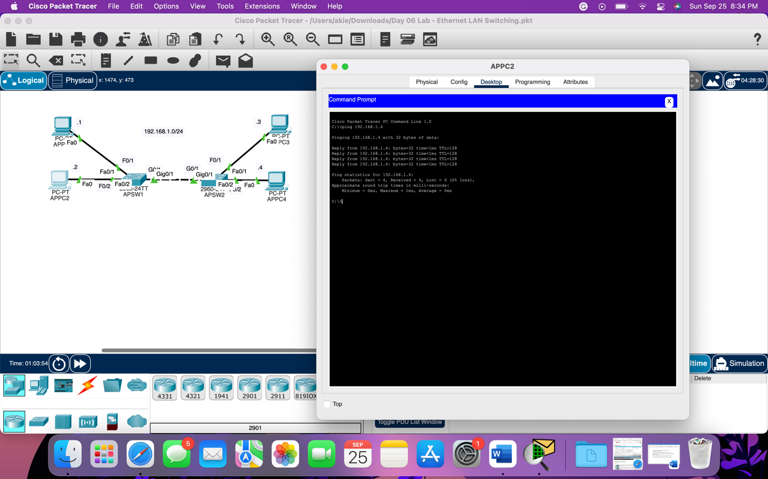

Use 'show' commands on the switches to identify the MAC address of each PC

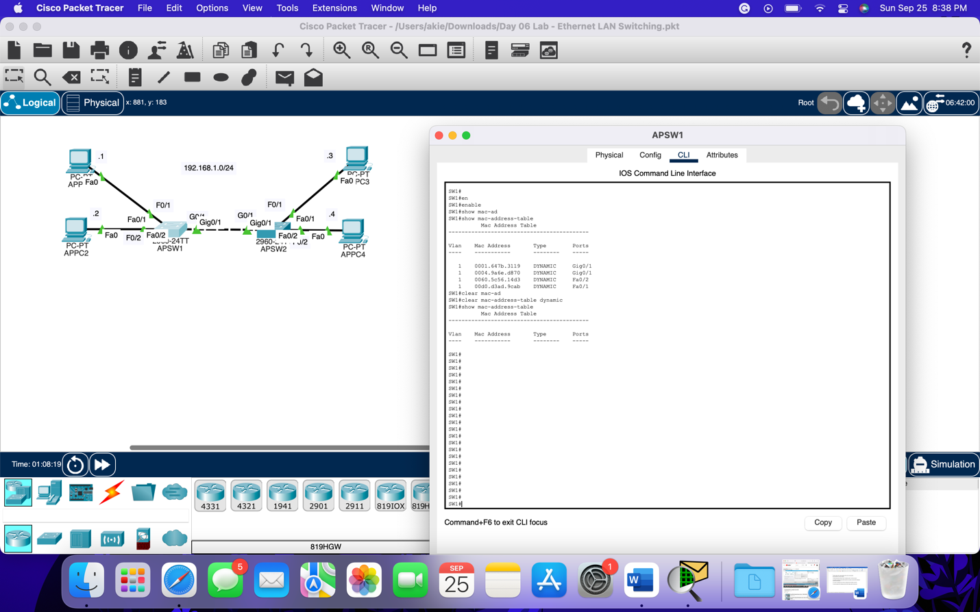

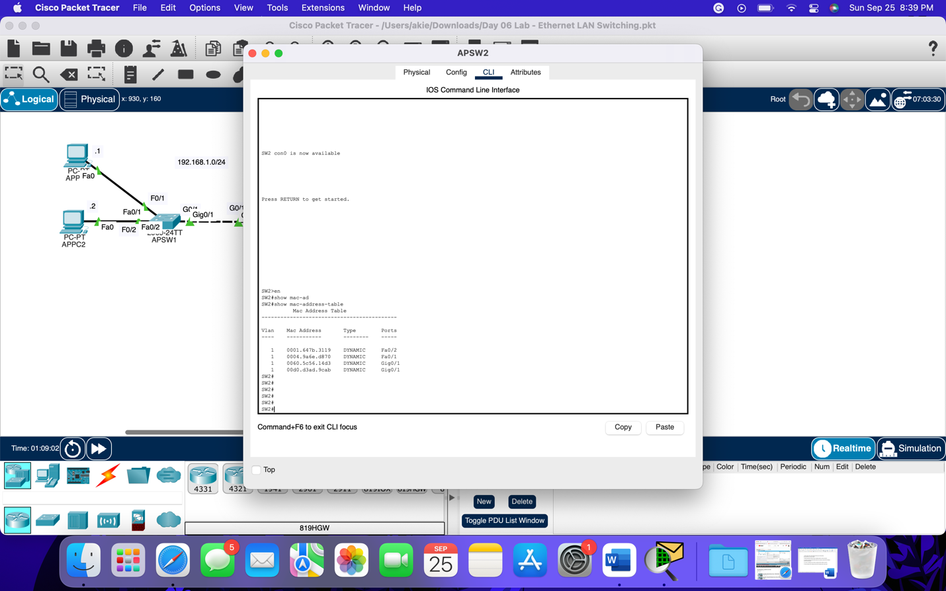

Clear the dynamic MAC addresses from the MAC address table of each switch.



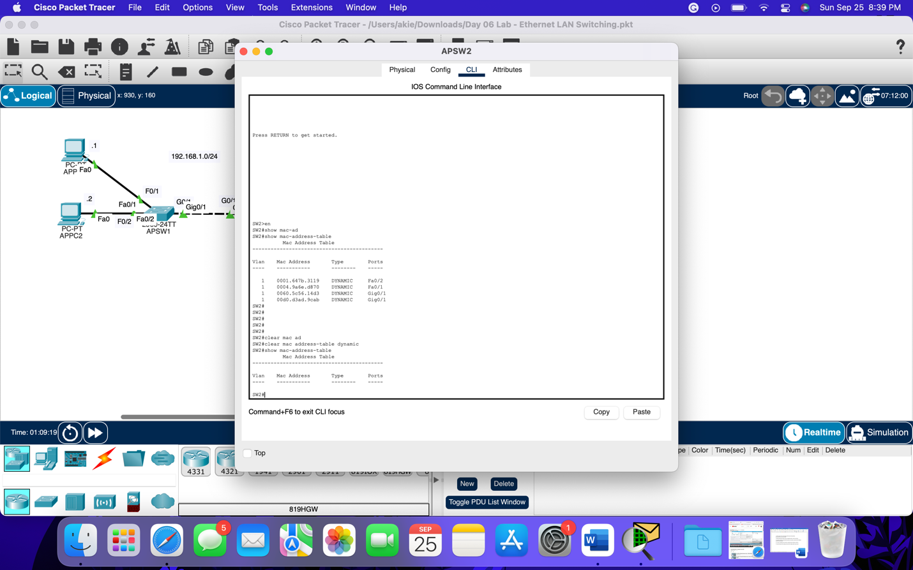

The time I took to complete this lab is 30 minutes, and I didn’t face any issues.

This lab helps me a lot to get in-detail knowledge about how packets are sent over the internet.

**LAB – 6:**

Configuring R1's hostname

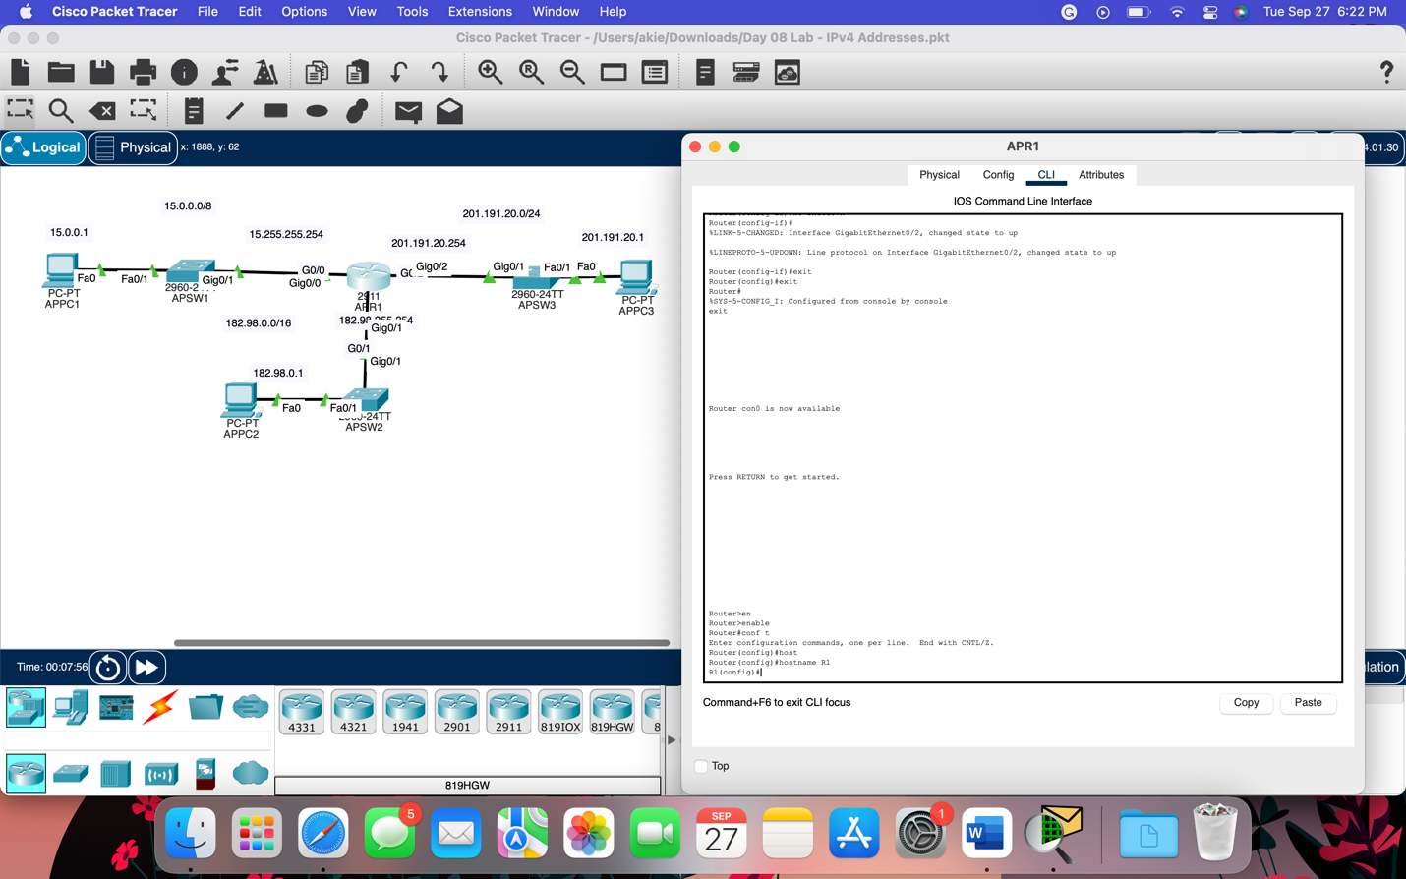

‘Show' command to view a list of R1's interfaces, their IP addresses, status, etc.

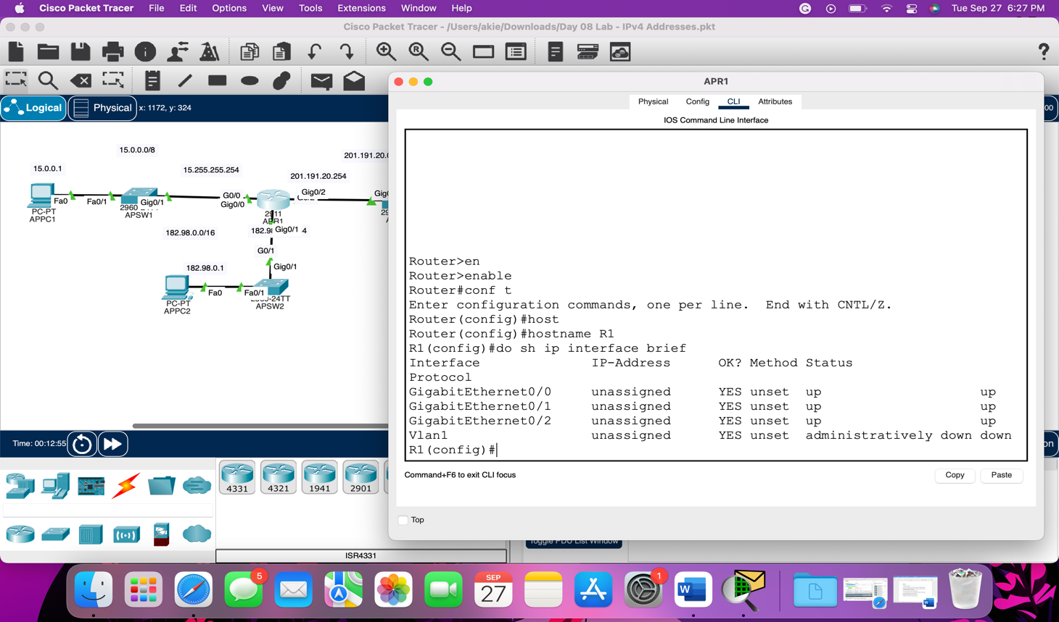

Configuring the appropriate IP addresses on R1's interfaces, and enabling the interfaces

Configuring appropriate interface descriptions

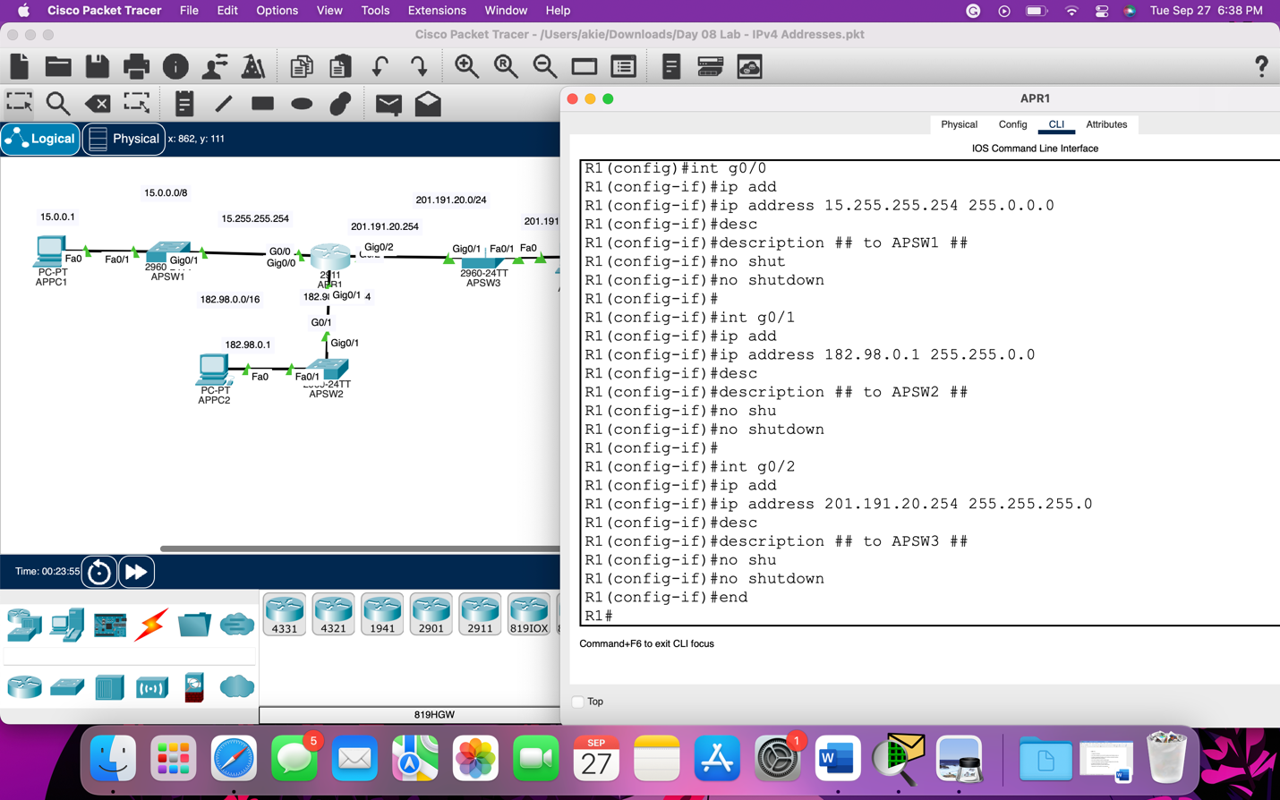

Using a 'show' command to verify R1's interfaces again

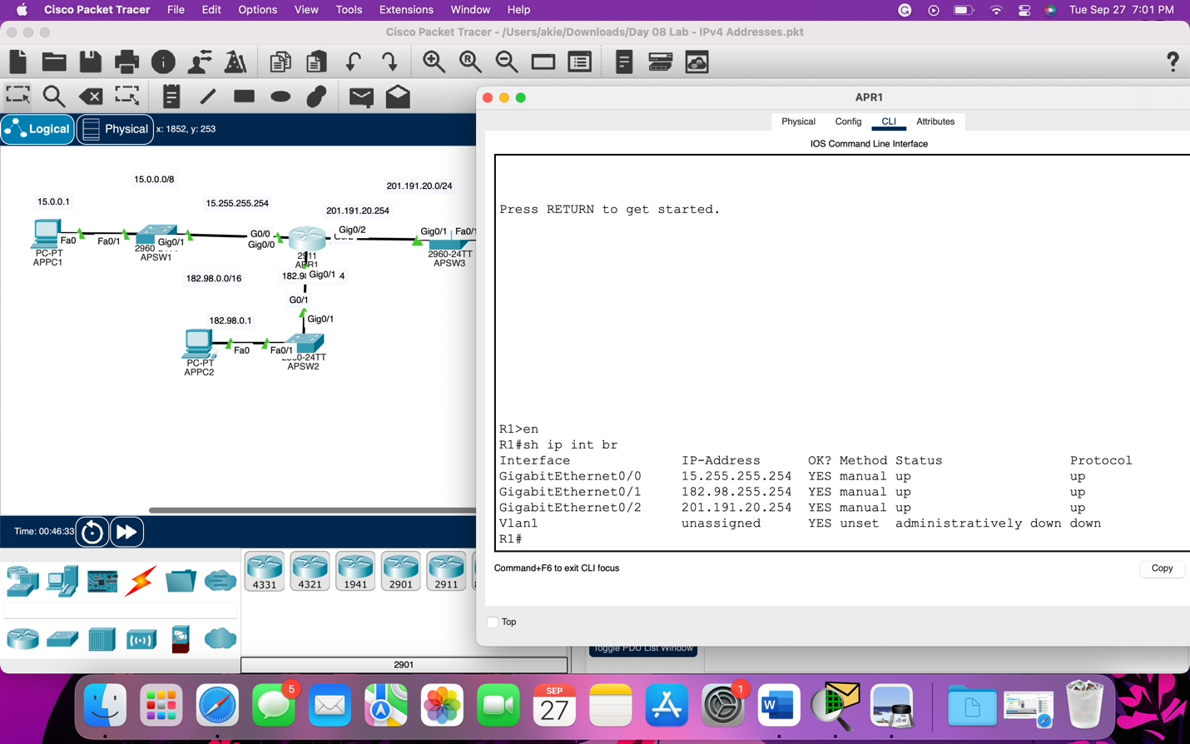

Viewing the running config to confirm the configuration changes, then saving the config

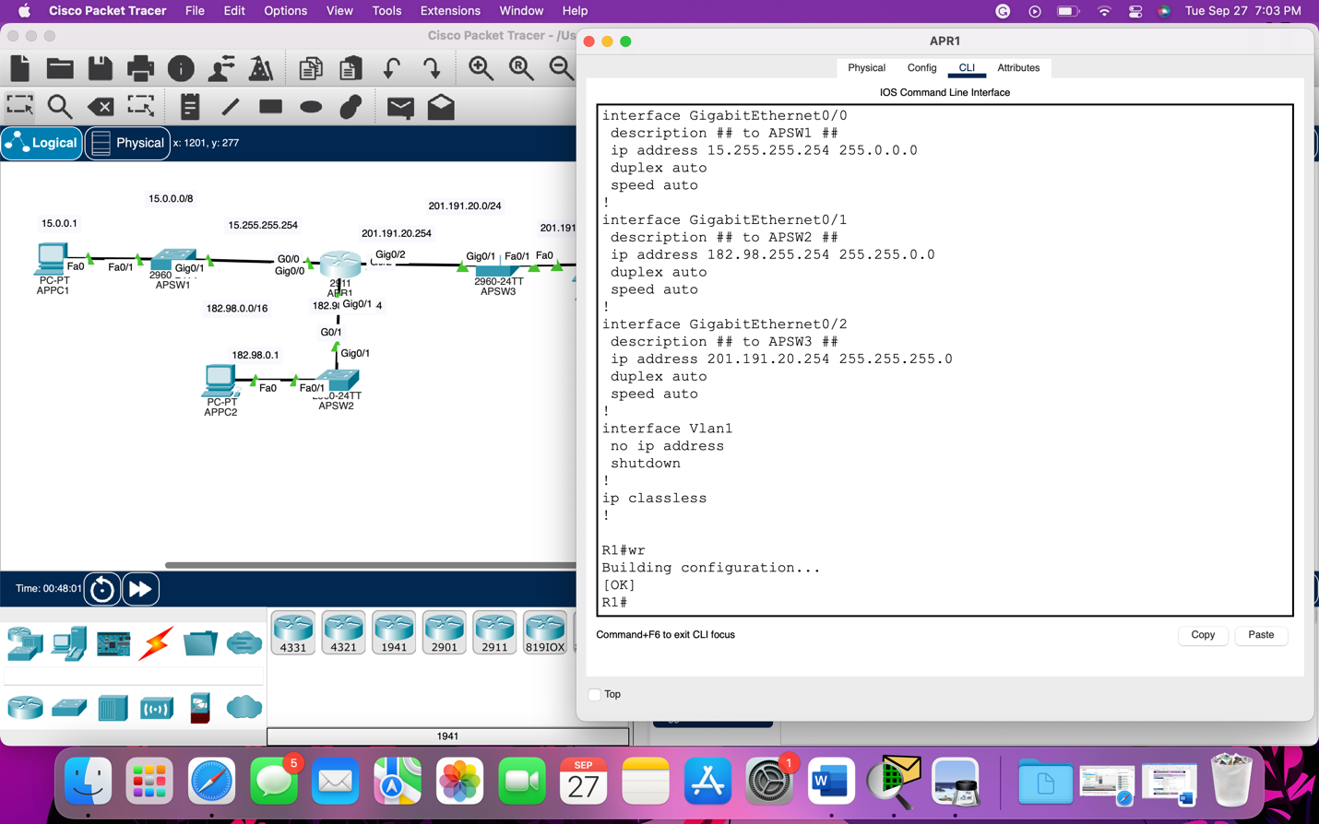

Configuring the IP addresses of PC1, PC2, and PC3

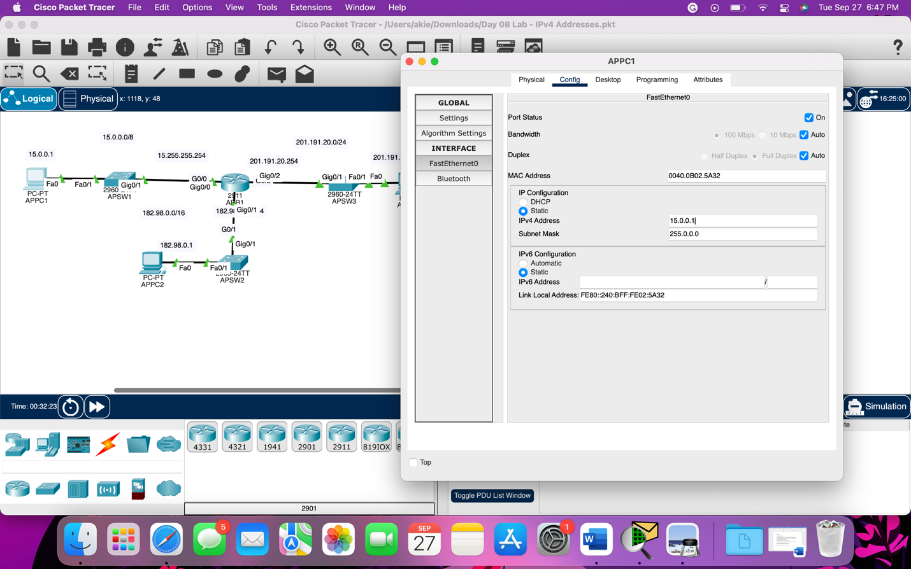

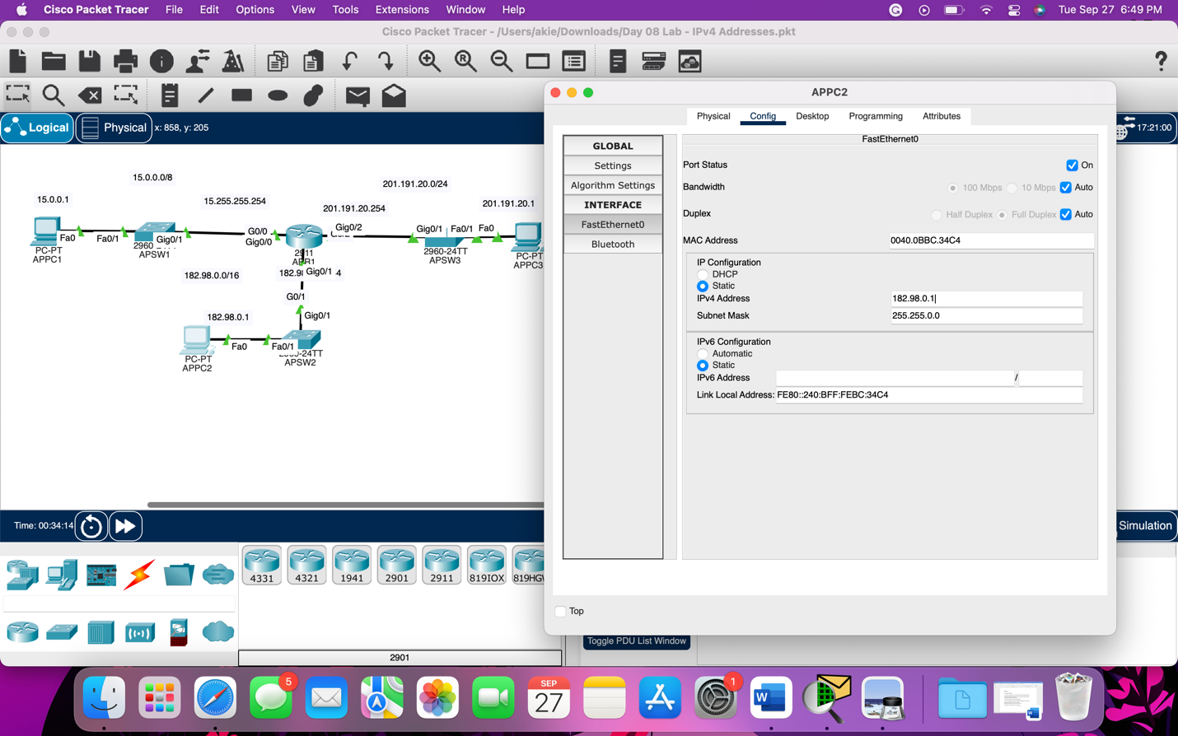

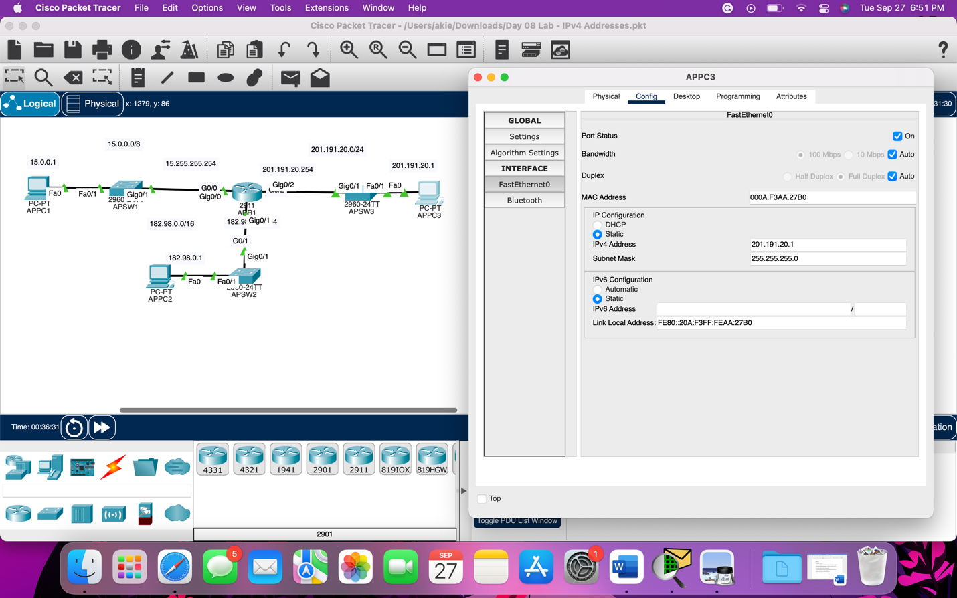

Pinging from PC1 to PC2 and PC3 to test connectivity

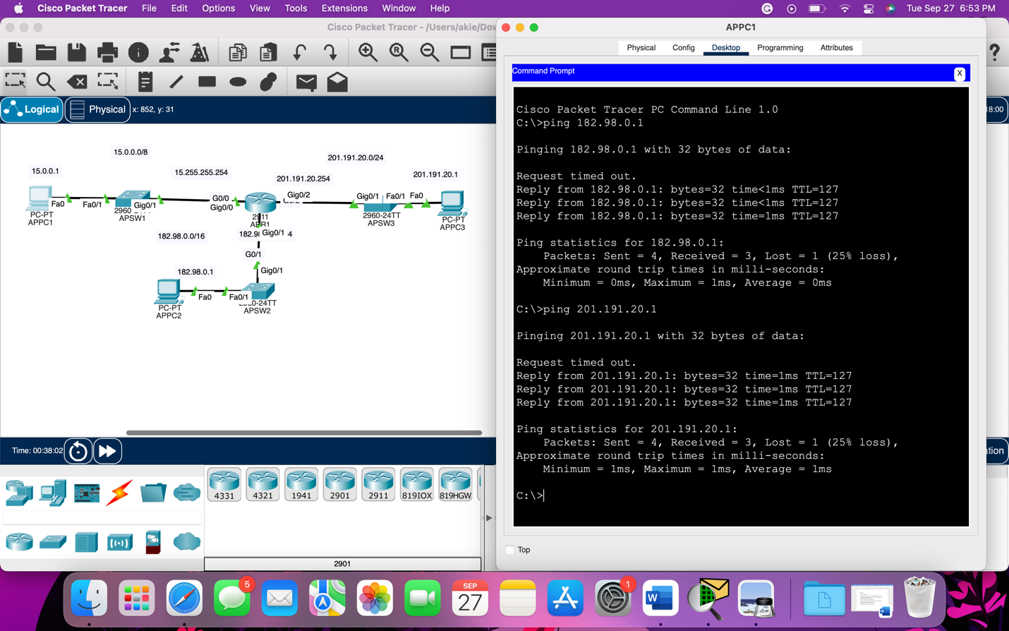

The Lab was completed in 40 minutes, I accidentally put the pc2 IP address in g0/1 but I fix it later on.